<http://localhost/glazbeni_katalog/index.php>

<http://localhost/phpmyadmin/sql.php?server=1&db=iwa_2021_vz_projekt&table=pjesma&pos=0>

<http://iwa.foi.hr/iwaprojekti/public/>

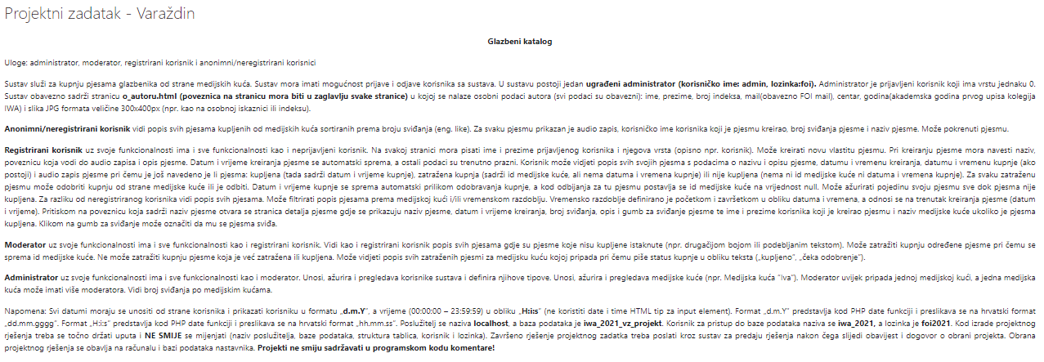

<https://www.youtube.com/channel/UCZtTN7Ug0o9n5zRTbEbHZtA/videos>

<https://www.youtube.com/watch?v=TLDMiTWR9c0>

[https://www.youtube.com/watch?v=lwgG_uIJYQM](%20https://www.youtube.com/watch?v=lwgG_uIJYQM)

<https://www.youtube.com/watch?v=6xdHq2YE0g8>

<https://www.youtube.com/watch?v=PBLuP2JZcEg>

<https://owlcation.com/stem/Simple-search-PHP-MySQL>